Отчёт по лабораторной работе №3

Computer Skills for Scientific Writing

Кодже Лемонго Арман

Содержание

Список иллюстраций

# Цель работы

This work presents LaTeX’s math mode and how we can type inline and display formulas, the extensions provided by the amsmath package, and how to change fonts in math.

# Exercises

1. Try out some basic math mode work: take the examples and switch between inline and display math modes. Can you see what effect this has.
2. Try adding other Greek letters, both lower- and uppercase. You should be able to guess the names.
3. Experiment with the font changing commands: what happens when you try to nest them?
4. Displayed math is centered by default; try adding the document class option [fleqn] (flush left equation) option to some of the above examples to see a different layout. Similarly equation numbers are usually on the right. Experiment with adding the [leqno] (left equation numbers) document class option.

# Выполнение работы

1. Try out some basic math mode work: take the examples and switch between inline and display math modes. Can you see what effect this has.

inline math mode is marked using a pair of dollar symbols ($...$). It is also possible to use the notation ( … ). Simple expressions are entered without any special markup, and you’ll see that the math is spaced out nicely and has letters in italic. You can use exactly the same commands for display math mode as for inline work. You can use exactly the same commands for display math mode as for inline work. Display math mode is set centered by default and is meant for larger equations that are ‘part of a paragraph’. Note that display math environments do not allow a paragraph to end within the mathematics, so you may not have blank lines within the source of the display. 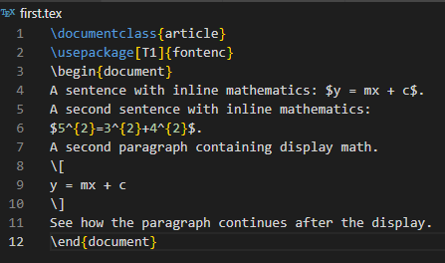{#fig 1 :inline and display math mode} 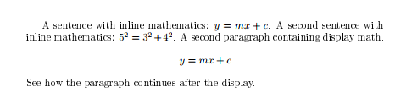{#fig 2 :compilations results inline and display math mode}

1. Try adding other Greek letters, both lower- and uppercase. You should be able to guess the names. There are a lot of specialist math mode commands. Some of them are quite easy, for example , , , … and for sine and logarithm or for the Greek letter. 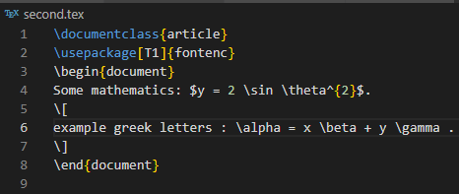{#fig 3 : Greek letters} 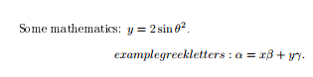{#fig 4 : compilations results Greek letters}
2. Experiment with the font changing commands: what happens when you try to nest them? Unlike normal text, font changes in math mode often convey very specific meaning. They are therefore often written explicitly. There are a set of commands you need here: • : roman (upright) • : italic spaced as ‘text’ • : boldface • : sans serif • : monospaced (typewriter) • : double-struck (blackboard bold) (provided by the amsfonts package)

For examples : 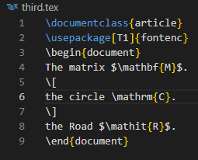{#fig 5 : Fonts in math mode} 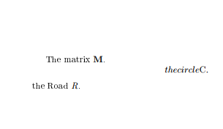{#fig 6 : ompilations results Fonts in math mode}

1. Displayed math is centered by default; try adding the document class option [fleqn] (flush left equation) option to some of the above examples to see a different layout. Similarly equation numbers are usually on the right. Experiment with adding the [leqno] (left equation numbers) document class option. 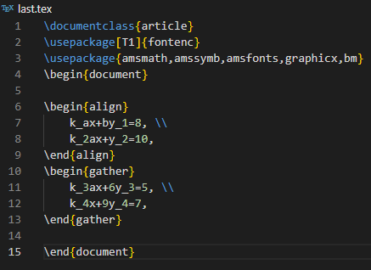{#fig 7 : class article } 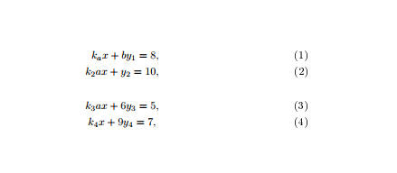{#fig 8 : compilations results class article}

fleqn: Makes display equations flush left instead of centered. Example: